**Tisha Choudhary**

**2055991583**

**BTech IT 6th Sem**

***FED Assignment 2***

Topic: Online Pawn shop

Pawnshops and pawn broking have been around for thousands of years. The basic idea behind

any pawnshop is to loan people money. It goes like this:

• You bring in something you own and give it to the pawnbroker as collateral for a loan

(This act is called pawning).

• The pawnbroker loans you money against that collateral.

• When you repay the loan plus the interest, you get your collateral back.

• If you don't repay the loan, the pawnbroker keeps the collateral.

**Codes:**

**pawn.html ->**

<!doctype html>

<html lang="en">

  <head>

    <meta charset="utf-8">

    <meta name="viewport" content="width=device-width, initial-scale=1">

    <title>Pawn Shop</title>

    <link rel="stylesheet" href="pawn.css">

    <link href="https://cdn.jsdelivr.net/npm/bootstrap@5.3.0-alpha1/dist/css/bootstrap.min.css" rel="stylesheet" integrity="sha384-GLhlTQ8iRABdZLl6O3oVMWSktQOp6b7In1Zl3/Jr59b6EGGoI1aFkw7cmDA6j6gD" crossorigin="anonymous">

  </head>

  <body>

    <nav class="navbar navbar-light navbar-expand-lg bg-light sticky-top">

        <div class="container-fluid">

          <a class="navbar-brand" href="#">Pawn Shop</a>

          <button class="navbar-toggler" type="button" data-bs-toggle="collapse" data-bs-target="#navbarSupportedContent" aria-controls="navbarSupportedContent" aria-expanded="false" aria-label="Toggle navigation">

            <span class="navbar-toggler-icon"></span>

          </button>

          <div class="collapse navbar-collapse" id="navbarSupportedContent">

            <ul class="navbar-nav me-auto mb-2 mb-lg-0">

              <li class="nav-item">

                <a class="nav-link active" aria-current="page" href="#">Home</a>

              </li>

              <li class="nav-item">

                <a class="nav-link" href="sell.html">Sell</a>

              </li>

              <li class="nav-item dropdown">

                <a class="nav-link dropdown-toggle" href="#" role="button" data-bs-toggle="dropdown" aria-expanded="false">

                  Loan

                </a>

                <ul class="dropdown-menu">

                  <li><a class="dropdown-item" href="loan.html">How pawn works?</a></li>

                  <li><hr class="dropdown-divider"></li>

                  <li><a class="dropdown-item" href="loan2.html">What can i pawn?</a></li>

                </ul>

              </li>

              <li class="nav-item">

                <a class="nav-link" href="about.html">About</a>

              </li>

            </ul>

            <nav class="navbar navbar-light bg-light">

                <form class="container-fluid justify-content-start">

                    <button type="button" class="btn btn-outline-danger me-2" data-bs-toggle="modal" data-bs-target="#exampleModal2">

                        Sign Up

                    </button>

                    <button type="button" class="btn btn-outline-danger me-2" data-bs-toggle="modal" data-bs-target="#exampleModal">

                        Login

                    </button>

                </form>

              </nav>

          </div>

        </div>

      </nav>

  <section id="intro">

    <div class="card_1">

      <div class="card_text">

        <h2>Loan - Shop - Sell</h2>

        <p>Providing easy cash solutions for millions of valued customers</p>

      </div>

      </div>

  </section>

  <section class="main-heading my-5">

    <div class="text-center">

        <h1 class="display-4">Our Services</h1>

        <hr class="w-25 mx-auto" />

    </div>

    <div class="container">

        <div class="row">

            <div class="col-md-8 col-10 col-xxl-4">

                <div class="card mb-3" style="max-width: 540px;">

                    <div class="row">

                      <div class="col-md-8 mx-auto">

                        <div class="card-body">

                          <h5 class="card-title text-center text-danger bg-gold">Loan</h5>

                          <p class="card-text">

                            Pawn loans are a quick and hassle-free way to access the cash you need. Our business is regulated and reputable and our team works hard to offer the highest dollar amount possible on any item you have of value. Remember, no credit necessary.

                        </p>

                        </div>

                      </div>

                    </div>

                  </div>

            </div>

            <div class="col-md-8 col-10 col-xxl-4">

                <div class="card mb-3" style="max-width: 540px;">

                    <div class="row">

                      <div class="col-md-8 mx-auto">

                        <div class="card-body">

                          <h5 class="card-title text-center text-danger bg-gold">Shop</h5>

                          <p class="card-text">

                            Our site is a great place to pick up a great deal on a broad range of unique items. You can expect to find significant savings over regular retail prices on pre-owned, brand name merchandise. We also offer payment options and a product protection plan.

                          </p>

                        </div>

                      </div>

                    </div>

                  </div>

            </div>

            <div class="col-md-8 col-10 col-xxl-4">

                <div class="card mb-3" style="max-width: 540px;">

                    <div class="row">

                      <div class="col-md-8 mx-auto">

                        <div class="card-body">

                          <h5 class="card-title text-center text-danger bg-gold">Sell</h5>

                          <p class="card-text">

                            Not interested in a pawn loan but would still like to convert items around your house into quick cash? Selling them is always an option. So avoid the hassle of online classified ads or garage sales and bring your items in for a free appraisal by our professional staff.

                          </p>

                        </div>

                      </div>

                    </div>

                  </div>

            </div>

        </div>

    </div>

  </section>

  <section id="intro2">

    <div class="card_2">

    <p>We are here for you! Have a cash need or are looking for a deal?

        We have all the cash you need. Obtaining a loan on one item or several items is fast and easy. Items are evaluated and appraised at the store.

        Need a smart TV, tablet or camera? What about a high-end handbag or quality watch for a fraction of the retail price? Our stores have a variety of items and part of the fun is the treasure hunt. Come see us!</p>

    </div>

  </section>

  <section class="main-heading my-5">

    <div class="text-center">

        <h1 class="display-4">Shop With Confidence</h1>

        <hr class="w-25 mx-auto" />

    </div>

    <div class="container">

        <div class="row">

            <div class="col-md-8 col-10 col-xxl-4">

                <div class="card mb-3" style="max-width: 540px;">

                    <div class="row">

                      <div class="col-md-13 mx-auto">

                        <div class="card-body">

                          <h5 class="card-title text-center text-danger bg-red">Layaway</h5>

                          <p class="card-text">

                            Layaway is a great way to lock in what you want at today’s low prices. (It also helps you to avoid those sky-high credit card interest rates.) With only 10% down you’ll get easy-to-afford payments and ensure you never miss out on a great deal. You make payments over time and pick up your items once you’ve made your final payment.

                        </p>

                        </div>

                      </div>

                    </div>

                  </div>

            </div>

            <div class="col-md-8 col-10 col-xxl-4">

                <div class="card mb-3" style="max-width: 540px;">

                    <div class="row">

                      <div class="col-md-13 mx-auto">

                        <div class="card-body">

                          <h5 class="card-title text-center text-danger bg-red">Product Protection Plan</h5>

                          <p class="card-text">

                            Protect your purchases and rest easy with our Product Protection Plan. For a small cost, you can have confidence in your purchase of items like computers, audio/video equipment and other merchandise. With our Product Protection Plan, you can shop with confidence.

                          </p>

                        </div>

                      </div>

                    </div>

                  </div>

            </div>

            <div class="col-md-8 col-10 col-xxl-4">

                <div class="card mb-3" style="max-width: 540px;">

                    <div class="row">

                      <div class="col-md-13 mx-auto">

                        <div class="card-body">

                          <h5 class="card-title text-center text-danger bg-red">Jewelry VIP Program</h5>

                          <p class="card-text">

                            Our Jewelry VIP Program is a great way to give yourself the option to swap your jewelry purchase without worrying about a loss. That’s because when you join the program, you’re eligible for 100% Trade-In Value on Future Jewelry Purchases.

                          </p>

                        </div>

                      </div>

                    </div>

                  </div>

            </div>

        </div>

    </div>

  </section>

  <section id="contact">

    <div class="text-center">

        <h1 class="display-4">Contact Us</h1>

        <hr class="w-25 mx-auto" />

    </div>

    <form class="card_3">

        <label for="name">Name:</label>

        <input type="text" id="name" name="name" required>

        <label for="email">Email:</label>

        <input type="email" id="email" name="email" required>

        <label for="message">Message:</label>

        <textarea id="message" name="message" required></textarea>

        <input type="submit" value="Send">

    </form>

</section>

</main>

<footer>

<p>&copy; 2023 Pawnshops and Pawnbroking. All rights reserved.</p>

</footer>

    <script src="https://cdn.jsdelivr.net/npm/bootstrap@5.3.0-alpha1/dist/js/bootstrap.bundle.min.js" integrity="sha384-w76AqPfDkMBDXo30jS1Sgez6pr3x5MlQ1ZAGC+nuZB+EYdgRZgiwxhTBTkF7CXvN" crossorigin="anonymous"></script>

</body>

</html>

Output:

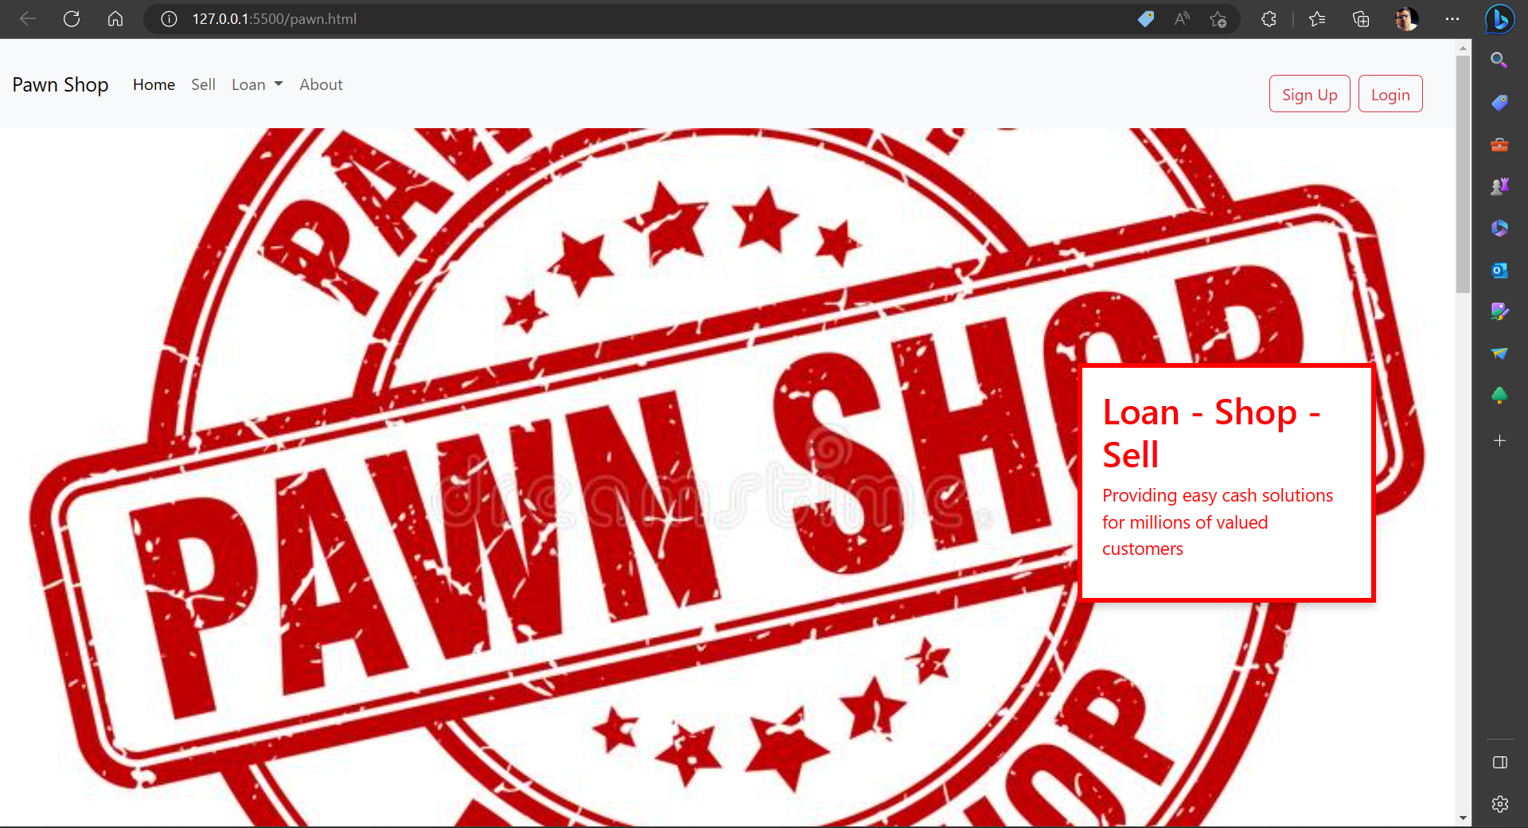

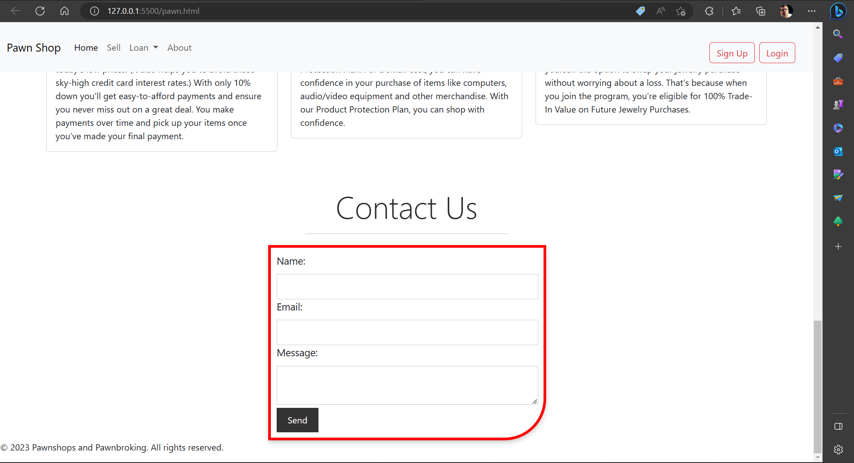

**loan.html ->**

<!doctype html>

<html lang="en">

  <head>

    <meta charset="utf-8">

    <meta name="viewport" content="width=device-width, initial-scale=1">

    <title>Pawn Shop</title>

    <link rel="stylesheet" href="pawn.css">

    <link href="https://cdn.jsdelivr.net/npm/bootstrap@5.3.0-alpha1/dist/css/bootstrap.min.css" rel="stylesheet" integrity="sha384-GLhlTQ8iRABdZLl6O3oVMWSktQOp6b7In1Zl3/Jr59b6EGGoI1aFkw7cmDA6j6gD" crossorigin="anonymous">

  </head>

  <body>

    <nav class="navbar navbar navbar-dark navbar-expand-lg bg-dark sticky-top">

        <div class="container-fluid">

          <a class="navbar-brand" href="pawn.html">Pawn Shop</a>

          <button class="navbar-toggler" type="button" data-bs-toggle="collapse" data-bs-target="#navbarSupportedContent" aria-controls="navbarSupportedContent" aria-expanded="false" aria-label="Toggle navigation">

            <span class="navbar-toggler-icon"></span>

          </button>

          <div class="collapse navbar-collapse" id="navbarSupportedContent">

            <ul class="navbar-nav me-auto mb-2 mb-lg-0">

              <li class="nav-item">

                <a class="nav-link active" aria-current="page" href="pawn.html">Home</a>

              </li>

              <li class="nav-item">

                <a class="nav-link" href="sell.html">Sell</a>

              </li>

              <li class="nav-item dropdown">

                <a class="nav-link dropdown-toggle" href="#" role="button" data-bs-toggle="dropdown" aria-expanded="false">

                  Loan

                </a>

                <ul class="dropdown-menu">

                  <li><a class="dropdown-item" href="#">How pawn works?</a></li>

                  <li><hr class="dropdown-divider"></li>

                  <li><a class="dropdown-item" href="loan2.html">What can i pawn?</a></li>

                </ul>

              </li>

              <li class="nav-item">

                <a class="nav-link" href="about.html">About</a>

              </li>

            </ul>

            <nav class="navbar navbar-dark bg-dark">

                <form class="container-fluid justify-content-start">

                    <button type="button" class="btn btn-outline-danger me-2" data-bs-toggle="modal" data-bs-target="#exampleModal2">

                        Sign Up

                    </button>

                    <button type="button" class="btn btn-outline-danger me-2" data-bs-toggle="modal" data-bs-target="#exampleModal">

                        Login

                    </button>

                </form>

              </nav>

          </div>

        </div>

      </nav>

  <div class="modal fade" id="exampleModal" tabindex="-1" aria-labelledby="exampleModalLabel" aria-hidden="true">

    <div class="modal-dialog">

      <div class="modal-content">

        <div class="modal-header">

          <h1 class="modal-title fs-5" id="exampleModalLabel">Login</h1>

          <button type="button" class="btn-close" data-bs-dismiss="modal" aria-label="Close"></button>

        </div>

        <div class="modal-body">

            <div class="mb-3">

                <label for="exampleFormControlInput1" class="form-label">Email address</label>

                <input type="email" class="form-control" id="exampleFormControlInput1" placeholder="name@example.com">

              </div>

                <label for="exampleFormControlInput1" class="form-label">Password</label>

                <input type="password" class="form-control" id="exampleFormControlInput1">

                <br>

              <button type="button" class="btn btn-primary">Login</button>

        </div>

      </div>

    </div>

  </div>

  <div class="modal fade" id="exampleModal2" tabindex="-1" aria-labelledby="exampleModalLabel" aria-hidden="true">

    <div class="modal-dialog">

      <div class="modal-content">

        <div class="modal-header">

          <h1 class="modal-title fs-5" id="exampleModalLabel">SignUp</h1>

          <button type="button" class="btn-close" data-bs-dismiss="modal" aria-label="Close"></button>

        </div>

        <div class="modal-body">

        </div>

      </div>

    </div>

  </div>

  <section id="intro3">

    <div class="text-center">

        <h2 class="display-4">Loans with no credit check</h2>

        <hr class="w-25 mx-auto text-danger bg-dark" />

        <p class="fs-4">Getting a loan requires just three fast and easy steps, and doesn’t require a credit check.</p>

    </div>

  </section>

  <br>

  <div class="text-center">

  <h2 class="display-4">how pawn works</h2>

  <hr class="w-25 mx-auto" />

</div>

  <div class="container">

  <div class="row">

    <div class="col-md-4">

      <div class="card mx-auto">

        <div class="card-body">

          <h5 class="card-title text-center text-danger bg-red">1. Bring in your item</h5>

          <p class="card-text">We lend on most items. No credit check and No hassle. Everyone qualifies. Must be 18 years of age (certain states may impose higher minimum ages). Valid Govt. issued ID required.</p>

          <a href="loan2.html" class="btn btn-danger">What kinds of items can I pawn?</a>

        </div>

      </div>

    </div>

    <div class="col-md-4">

      <div class="card mx-auto">

        <div class="card-body">

          <h5 class="card-title text-center text-danger bg-red">2. Get a loan</h5>

          <p class="card-text">We’ll appraise your item and let you know the cash amount we are able to lend. We then hold your item and you leave with cash. The time period for the loan varies depending on state law. And rest assured, when your item is in our care, we keep it safe and secure.</p>

        </div>

      </div>

    </div>

    <div class="col-md-4">

      <div class="card mx-auto">

        <div class="card-body">

          <h5 class="card-title text-center text-danger bg-red">3. Pay back your loan</h5>

          <p class="card-text">To retrieve your item, just pay off your loan. Of course, should you need more time, we offer extensions and renewals, as permitted by law. If you choose to surrender your collateral, there is nothing further you need to do. You are free to not pay off your loan without judgment or any impact on your credit score. Repay your pawn loan to retrieve your merchandise.</p>

        </div>

      </div>

    </div>

  </div>

</div>

<hr>

  <section id="contact">

    <div class="text-center">

        <h1 class="display-4">Contact Us</h1>

        <hr class="w-25 mx-auto" />

    </div>

    <form class="card_3">

        <label for="name">Name:</label>

        <input type="text" id="name" name="name" required>

        <label for="email">Email:</label>

        <input type="email" id="email" name="email" required>

        <label for="message">Message:</label>

        <textarea id="message" name="message" required></textarea>

        <input type="submit" value="Send">

    </form>

</section>

</main>

<footer>

<p>&copy; 2023 Pawnshops and Pawnbroking. All rights reserved.</p>

</footer>

    <script src="https://cdn.jsdelivr.net/npm/bootstrap@5.3.0-alpha1/dist/js/bootstrap.bundle.min.js" integrity="sha384-w76AqPfDkMBDXo30jS1Sgez6pr3x5MlQ1ZAGC+nuZB+EYdgRZgiwxhTBTkF7CXvN" crossorigin="anonymous"></script>

</body>

</html>

Output:

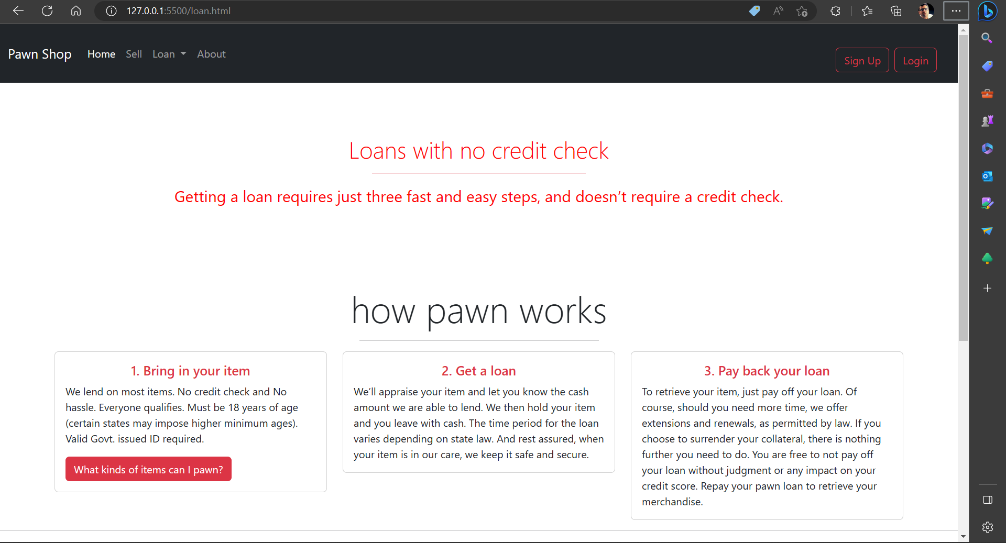

**loan2.html ->**

<!doctype html>

<html lang="en">

  <head>

    <meta charset="utf-8">

    <meta name="viewport" content="width=device-width, initial-scale=1">

    <title>Pawn Shop</title>

    <link rel="stylesheet" href="pawn.css">

    <link href="https://cdn.jsdelivr.net/npm/bootstrap@5.3.0-alpha1/dist/css/bootstrap.min.css" rel="stylesheet" integrity="sha384-GLhlTQ8iRABdZLl6O3oVMWSktQOp6b7In1Zl3/Jr59b6EGGoI1aFkw7cmDA6j6gD" crossorigin="anonymous">

  </head>

  <body>

    <nav class="navbar navbar navbar-dark navbar-expand-lg bg-dark sticky-top">

        <div class="container-fluid">

          <a class="navbar-brand" href="pawn.html">Pawn Shop</a>

          <button class="navbar-toggler" type="button" data-bs-toggle="collapse" data-bs-target="#navbarSupportedContent" aria-controls="navbarSupportedContent" aria-expanded="false" aria-label="Toggle navigation">

            <span class="navbar-toggler-icon"></span>

          </button>

          <div class="collapse navbar-collapse" id="navbarSupportedContent">

            <ul class="navbar-nav me-auto mb-2 mb-lg-0">

              <li class="nav-item">

                <a class="nav-link active" aria-current="page" href="pawn.html">Home</a>

              </li>

              <li class="nav-item">

                <a class="nav-link" href="sell.html">Sell</a>

              </li>

              <li class="nav-item dropdown">

                <a class="nav-link dropdown-toggle" href="#" role="button" data-bs-toggle="dropdown" aria-expanded="false">

                  Loan

                </a>

                <ul class="dropdown-menu">

                  <li><a class="dropdown-item" href="loan.html">How pawn works?</a></li>

                  <li><hr class="dropdown-divider"></li>

                  <li><a class="dropdown-item" href="#">What can i pawn?</a></li>

                </ul>

              </li>

              <li class="nav-item">

                <a class="nav-link" href="about.html">About</a>

              </li>

            </ul>

            <nav class="navbar navbar-dark bg-dark">

                <form class="container-fluid justify-content-start">

                    <button type="button" class="btn btn-outline-danger me-2" data-bs-toggle="modal" data-bs-target="#exampleModal2">

                        Sign Up

                    </button>

                    <button type="button" class="btn btn-outline-danger me-2" data-bs-toggle="modal" data-bs-target="#exampleModal">

                        Login

                    </button>

                </form>

              </nav>

          </div>

        </div>

      </nav>

  <div class="modal fade" id="exampleModal" tabindex="-1" aria-labelledby="exampleModalLabel" aria-hidden="true">

    <div class="modal-dialog">

      <div class="modal-content">

        <div class="modal-header">

          <h1 class="modal-title fs-5" id="exampleModalLabel">Login</h1>

          <button type="button" class="btn-close" data-bs-dismiss="modal" aria-label="Close"></button>

        </div>

        <div class="modal-body">

            <div class="mb-3">

                <label for="exampleFormControlInput1" class="form-label">Email address</label>

                <input type="email" class="form-control" id="exampleFormControlInput1" placeholder="name@example.com">

              </div>

                <label for="exampleFormControlInput1" class="form-label">Password</label>

                <input type="password" class="form-control" id="exampleFormControlInput1">

                <br>

              <button type="button" class="btn btn-primary">Login</button>

        </div>

      </div>

    </div>

  </div>

  <div class="modal fade" id="exampleModal2" tabindex="-1" aria-labelledby="exampleModalLabel" aria-hidden="true">

    <div class="modal-dialog">

      <div class="modal-content">

        <div class="modal-header">

          <h1 class="modal-title fs-5" id="exampleModalLabel">SignUp</h1>

          <button type="button" class="btn-close" data-bs-dismiss="modal" aria-label="Close"></button>

        </div>

        <div class="modal-body">

        </div>

      </div>

    </div>

  </div>

  <section id="intro3">

    <div class="text-center">

        <h2 class="display-4">What Can I Pawn?</h2>

        <hr class="w-25 mx-auto text-danger bg-dark" />

        <p class="fs-4">You can get a pawn loan using a wide range of merchandise as collateral.</p>

    </div>

  </section>

  <br>

  <div class="container my-4">

    <div class="row featurette d-flex justify-content-center align-items-center">

        <div class="col-md-7">

            <h2 class="featurette-heading">We’ll Take Just About Anything of Value</h2>

            <p class="lead">Common items we take as security include but are not limited to:

            <ol>

                <li>Cameras</li>

                <li> Collectibles</li>

                <li>Firearms*</li>

                <li> Jewelry</li>

                <li> Musical Instruments</li>

                <li> Power Tools</li>

                <li> Smart TVs</li>

                <li> Smartphones</li>

                <li> Video Game Consoles</li>

                <li> Watches</li>

            </ol>

            </p>

        </div>

        <div class="col-md-5">

            <img class="img-fluid" src="pawn-shop.jpg" alt="">

        </div>

    </div>

<hr>

  <section id="contact">

    <div class="text-center">

        <h1 class="display-4">Contact Us</h1>

        <hr class="w-25 mx-auto" />

    </div>

    <form class="card_3">

        <label for="name">Name:</label>

        <input type="text" id="name" name="name" required>

        <label for="email">Email:</label>

        <input type="email" id="email" name="email" required>

        <label for="message">Message:</label>

        <textarea id="message" name="message" required></textarea>

        <input type="submit" value="Send">

    </form>

</section>

</main>

<footer>

<p>&copy; 2023 Pawnshops and Pawnbroking. All rights reserved.</p>

</footer>

    <script src="https://cdn.jsdelivr.net/npm/bootstrap@5.3.0-alpha1/dist/js/bootstrap.bundle.min.js" integrity="sha384-w76AqPfDkMBDXo30jS1Sgez6pr3x5MlQ1ZAGC+nuZB+EYdgRZgiwxhTBTkF7CXvN" crossorigin="anonymous"></script>

</body>

</html>

Output:

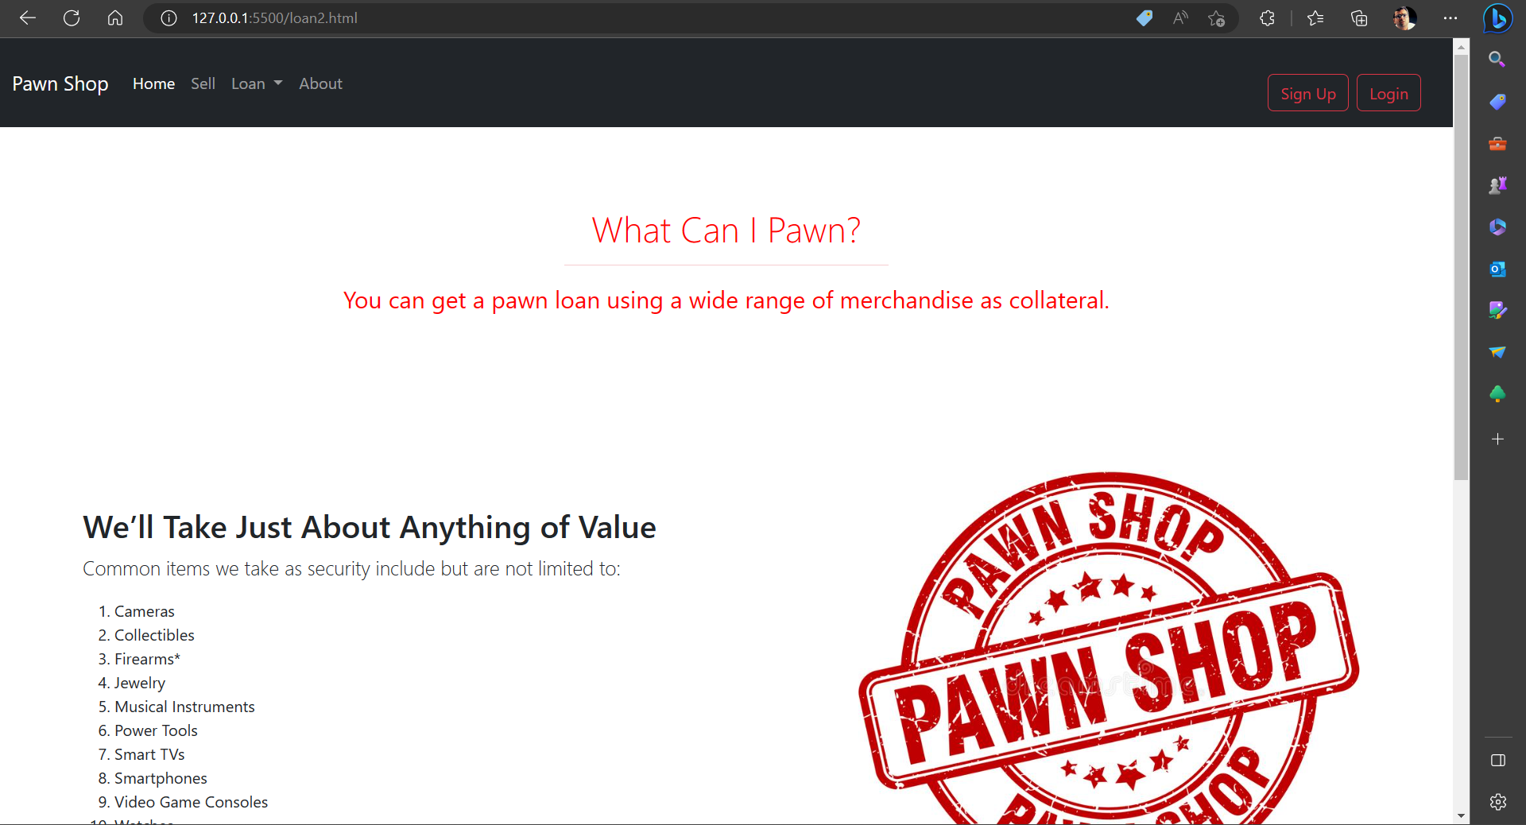

**sell.html ->**

<!doctype html>

<html lang="en">

  <head>

    <meta charset="utf-8">

    <meta name="viewport" content="width=device-width, initial-scale=1">

    <title>Pawn Shop</title>

    <link rel="stylesheet" href="pawn.css">

    <link href="https://cdn.jsdelivr.net/npm/bootstrap@5.3.0-alpha1/dist/css/bootstrap.min.css" rel="stylesheet" integrity="sha384-GLhlTQ8iRABdZLl6O3oVMWSktQOp6b7In1Zl3/Jr59b6EGGoI1aFkw7cmDA6j6gD" crossorigin="anonymous">

  </head>

  <body>

    <nav class="navbar navbar navbar-dark navbar-expand-lg bg-dark sticky-top">

        <div class="container-fluid">

          <a class="navbar-brand" href="pawn.html">Pawn Shop</a>

          <button class="navbar-toggler" type="button" data-bs-toggle="collapse" data-bs-target="#navbarSupportedContent" aria-controls="navbarSupportedContent" aria-expanded="false" aria-label="Toggle navigation">

            <span class="navbar-toggler-icon"></span>

          </button>

          <div class="collapse navbar-collapse" id="navbarSupportedContent">

            <ul class="navbar-nav me-auto mb-2 mb-lg-0">

              <li class="nav-item">

                <a class="nav-link active" aria-current="page" href="pawn.html">Home</a>

              </li>

              <li class="nav-item">

                <a class="nav-link" href="#">Sell</a>

              </li>

              <li class="nav-item dropdown">

                <a class="nav-link dropdown-toggle" href="#" role="button" data-bs-toggle="dropdown" aria-expanded="false">

                  Loan

                </a>

                <ul class="dropdown-menu">

                  <li><a class="dropdown-item" href="loan.html">How pawn works?</a></li>

                  <li><hr class="dropdown-divider"></li>

                  <li><a class="dropdown-item" href="loan2.html">What can i pawn?</a></li>

                </ul>

              </li>

              <li class="nav-item">

                <a class="nav-link" href="about.html">About</a>

              </li>

            </ul>

            <nav class="navbar navbar-dark bg-dark">

                <form class="container-fluid justify-content-start">

                    <button type="button" class="btn btn-outline-danger me-2" data-bs-toggle="modal" data-bs-target="#exampleModal2">

                        Sign Up

                    </button>

                    <button type="button" class="btn btn-outline-danger me-2" data-bs-toggle="modal" data-bs-target="#exampleModal">

                        Login

                    </button>

                </form>

              </nav>

          </div>

        </div>

      </nav>

  <div class="modal fade" id="exampleModal" tabindex="-1" aria-labelledby="exampleModalLabel" aria-hidden="true">

    <div class="modal-dialog">

      <div class="modal-content">

        <div class="modal-header">

          <h1 class="modal-title fs-5" id="exampleModalLabel">Login</h1>

          <button type="button" class="btn-close" data-bs-dismiss="modal" aria-label="Close"></button>

        </div>

        <div class="modal-body">

            <div class="mb-3">

                <label for="exampleFormControlInput1" class="form-label">Email address</label>

                <input type="email" class="form-control" id="exampleFormControlInput1" placeholder="name@example.com">

              </div>

                <label for="exampleFormControlInput1" class="form-label">Password</label>

                <input type="password" class="form-control" id="exampleFormControlInput1">

                <br>

              <button type="button" class="btn btn-primary">Login</button>

        </div>

      </div>

    </div>

  </div>

  <div class="modal fade" id="exampleModal2" tabindex="-1" aria-labelledby="exampleModalLabel" aria-hidden="true">

    <div class="modal-dialog">

      <div class="modal-content">

        <div class="modal-header">

          <h1 class="modal-title fs-5" id="exampleModalLabel">SignUp</h1>

          <button type="button" class="btn-close" data-bs-dismiss="modal" aria-label="Close"></button>

        </div>

        <div class="modal-body">

        </div>

      </div>

    </div>

  </div>

  <section id="intro3">

    <div class="text-center">

        <h2 class="display-4">Can I sell my items?</h2>

        <hr class="w-25 mx-auto text-danger bg-dark" />

        <p class="fs-4">Yes! We buy a wide range of goods and always work to give you top dollar for your items.</p>

    </div>

  </section>

  <div class="container my-4">

    <div class="row featurette d-flex justify-content-center align-items-center">

        <div class="col-md-7">

            <h2 class="featurette-heading">We’ll Buy Just About Anything of Value</h2>

            <p class="lead">No need to wait for a buyer when you need immediate cash. We’ll buy almost anything of

                value. Common items we buy

                include but are not limited to:

            <ol>

                <li>Cameras</li>

                <li> Collectibles</li>

                <li>Firearms*</li>

                <li> Jewelry</li>

                <li> Musical Instruments</li>

                <li> Power Tools</li>

                <li> Smart TVs</li>

                <li> Smartphones</li>

                <li> Video Game Consoles</li>

                <li> Watches</li>

            </ol>

            </p>

        </div>

        <div class="col-md-5">

            <img class="img-fluid" src="pawn-shop.jpg" alt="">

        </div>

    </div>

<hr>

  <section id="contact">

    <div class="text-center">

        <h1 class="display-4">Contact Us</h1>

        <hr class="w-25 mx-auto" />

    </div>

    <form class="card_3">

        <label for="name">Name:</label>

        <input type="text" id="name" name="name" required>

        <label for="email">Email:</label>

        <input type="email" id="email" name="email" required>

        <label for="message">Message:</label>

        <textarea id="message" name="message" required></textarea>

        <input type="submit" value="Send">

    </form>

</section>

</main>

<footer>

<p>&copy; 2023 Pawnshops and Pawnbroking. All rights reserved.</p>

</footer>

    <script src="https://cdn.jsdelivr.net/npm/bootstrap@5.3.0-alpha1/dist/js/bootstrap.bundle.min.js" integrity="sha384-w76AqPfDkMBDXo30jS1Sgez6pr3x5MlQ1ZAGC+nuZB+EYdgRZgiwxhTBTkF7CXvN" crossorigin="anonymous"></script>

</body>

</html>

Output:

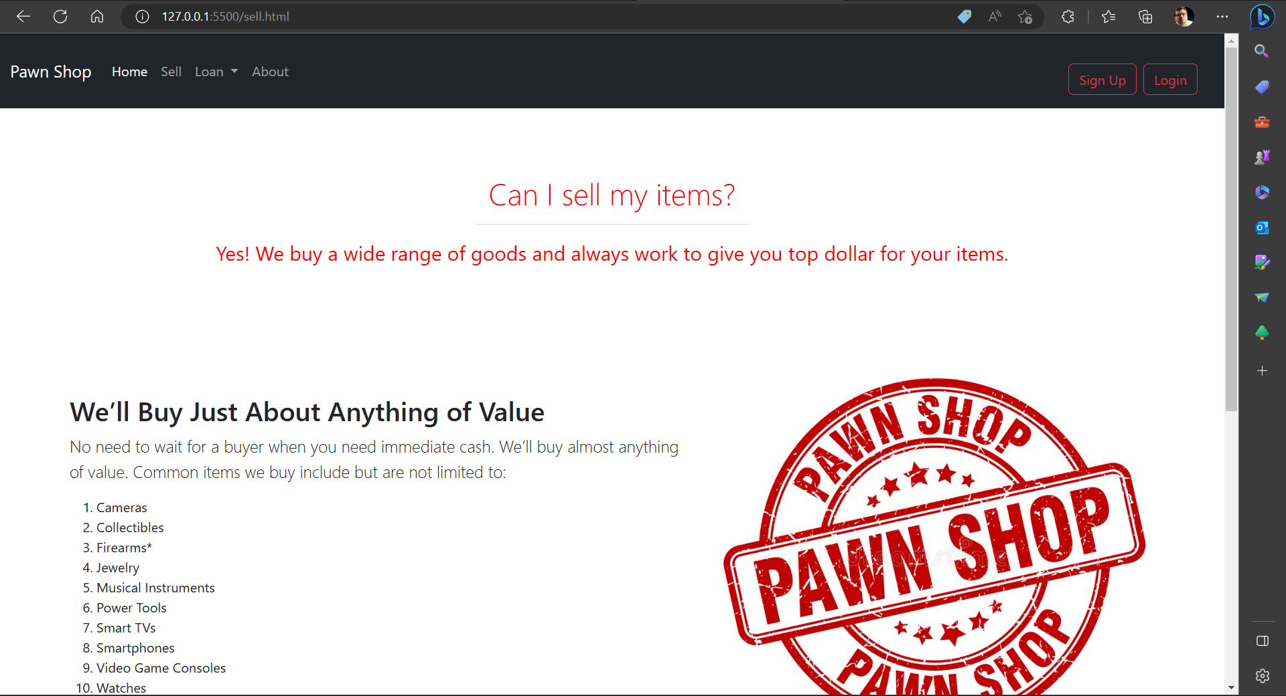

**about.html ->**

<!doctype html>

<html lang="en">

  <head>

    <meta charset="utf-8">

    <meta name="viewport" content="width=device-width, initial-scale=1">

    <title>Pawn Shop</title>

    <link rel="stylesheet" href="pawn.css">

    <link href="https://cdn.jsdelivr.net/npm/bootstrap@5.3.0-alpha1/dist/css/bootstrap.min.css" rel="stylesheet" integrity="sha384-GLhlTQ8iRABdZLl6O3oVMWSktQOp6b7In1Zl3/Jr59b6EGGoI1aFkw7cmDA6j6gD" crossorigin="anonymous">

  </head>

  <body>

    <nav class="navbar navbar navbar-dark navbar-expand-lg bg-dark sticky-top">

        <div class="container-fluid">

          <a class="navbar-brand" href="pawn.html">Pawn Shop</a>

          <button class="navbar-toggler" type="button" data-bs-toggle="collapse" data-bs-target="#navbarSupportedContent" aria-controls="navbarSupportedContent" aria-expanded="false" aria-label="Toggle navigation">

            <span class="navbar-toggler-icon"></span>

          </button>

          <div class="collapse navbar-collapse" id="navbarSupportedContent">

            <ul class="navbar-nav me-auto mb-2 mb-lg-0">

              <li class="nav-item">

                <a class="nav-link active" aria-current="page" href="pawn.html">Home</a>

              </li>

              <li class="nav-item">

                <a class="nav-link" href="sell.html">Sell</a>

              </li>

              <li class="nav-item dropdown">

                <a class="nav-link dropdown-toggle" href="#" role="button" data-bs-toggle="dropdown" aria-expanded="false">

                  Loan

                </a>

                <ul class="dropdown-menu">

                  <li><a class="dropdown-item" href="loan.html">How pawn works?</a></li>

                  <li><hr class="dropdown-divider"></li>

                  <li><a class="dropdown-item" href="loan2.html">What can i pawn?</a></li>

                </ul>

              </li>

              <li class="nav-item">

                <a class="nav-link" href="#">About</a>

              </li>

            </ul>

            <nav class="navbar navbar-dark bg-dark">

                <form class="container-fluid justify-content-start">

                    <button type="button" class="btn btn-outline-danger me-2" data-bs-toggle="modal" data-bs-target="#exampleModal2">

                        Sign Up

                    </button>

                    <button type="button" class="btn btn-outline-danger me-2" data-bs-toggle="modal" data-bs-target="#exampleModal">

                        Login

                    </button>

                </form>

              </nav>

          </div>

        </div>

      </nav>

  <div class="modal fade" id="exampleModal" tabindex="-1" aria-labelledby="exampleModalLabel" aria-hidden="true">

    <div class="modal-dialog">

      <div class="modal-content">

        <div class="modal-header">

          <h1 class="modal-title fs-5" id="exampleModalLabel">Login</h1>

          <button type="button" class="btn-close" data-bs-dismiss="modal" aria-label="Close"></button>

        </div>

        <div class="modal-body">

            <div class="mb-3">

                <label for="exampleFormControlInput1" class="form-label">Email address</label>

                <input type="email" class="form-control" id="exampleFormControlInput1" placeholder="name@example.com">

              </div>

                <label for="exampleFormControlInput1" class="form-label">Password</label>

                <input type="password" class="form-control" id="exampleFormControlInput1">

                <br>

              <button type="button" class="btn btn-primary">Login</button>

        </div>

      </div>

    </div>

  </div>

  <div class="modal fade" id="exampleModal2" tabindex="-1" aria-labelledby="exampleModalLabel" aria-hidden="true">

    <div class="modal-dialog">

      <div class="modal-content">

        <div class="modal-header">

          <h1 class="modal-title fs-5" id="exampleModalLabel">SignUp</h1>

          <button type="button" class="btn-close" data-bs-dismiss="modal" aria-label="Close"></button>

        </div>

        <div class="modal-body">

        </div>

      </div>

    </div>

  </div>

  <section>

  <br>

  <br>

    <div class="text-center">

        <h2 class="display-4">About Us</h2>

        <hr class="w-25 mx-auto" />

        <p class="fs-4">We welcomed our first customers in 1974 in Austin, Texas. A lot of years have passed and millions of customers served, yet everyday we still work to make our customers’ lives easier. Today, at more than 500 pawn shops nationwide, we help hardworking, everyday people get quick access to cash and brand-name merchandise by pawning or selling quality items. From beginning to end, we take pride in making the process easy. We never lose sight of our promise to deliver great customer service.</p>

    </div>

  </section>

  <br>

  <div class="container my-4">

    <div class="row featurette d-flex justify-content-center align-items-center text-danger bg-dark">

        <div class="col-md-7">

      <div class="text-left">

        <h2 class="display-4">Our Values</h2>

        <hr class="w-25 text-danger bg-red" />

      </div>

            <h2 class="featurette-heading">People Matter Most</h2>

            <ul>

                <li>Customer experience...treat our customers as we would want to be treated</li>

                <li>Passionate, Friendly, and Knowledgeable Team Members</li>

                <li>Community involvement...we're part of your community and work to make it better for all of us.</li>

            </ul>

            <h2 class="featurette-heading">We Deliver Solutions For Our Customers</h2>

            <ul>

                <li>Varied Geographies, Delivery Mechanism, Formats, and Products</li>

                <li>Always Transparent</li>

                <li>Online access for our customers' convenience</li>

            </ul>

            <h2 class="featurette-heading">We Deliver On Our Commitments</h2>

            <ul>

                <li>As a Team</li>

                <li>With honest, Integrity, and Respect</li>

            </ul>

        </div>

        <div class="col-md-5">

            <img class="img-fluid" src="pawn-shop.jpg" alt="">

        </div>

    </div>

<hr>

  <section id="contact">

    <div class="text-center">

        <h1 class="display-4">Contact Us</h1>

        <hr class="w-25 mx-auto" />

    </div>

    <form class="card_3">

        <label for="name">Name:</label>

        <input type="text" id="name" name="name" required>

        <label for="email">Email:</label>

        <input type="email" id="email" name="email" required>

        <label for="message">Message:</label>

        <textarea id="message" name="message" required></textarea>

        <input type="submit" value="Send">

    </form>

</section>

</main>

<footer>

<p>&copy; 2023 Pawnshops and Pawnbroking. All rights reserved.</p>

</footer>

    <script src="https://cdn.jsdelivr.net/npm/bootstrap@5.3.0-alpha1/dist/js/bootstrap.bundle.min.js" integrity="sha384-w76AqPfDkMBDXo30jS1Sgez6pr3x5MlQ1ZAGC+nuZB+EYdgRZgiwxhTBTkF7CXvN" crossorigin="anonymous"></script>

</body>

</html>

Output:

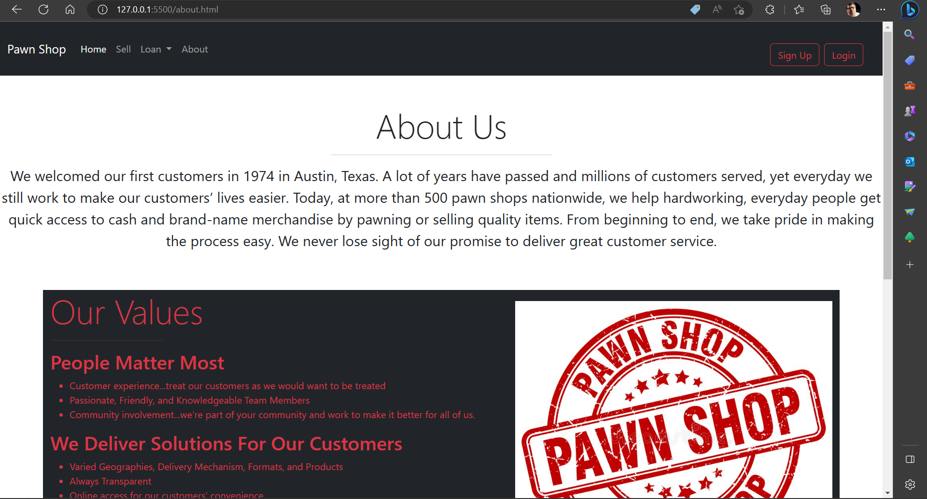

**pawn.css ->**

#intro {

*background-image*: url("pawn-shop.jpg");

*height*: 90vh;

*background-repeat*: no-repeat;

*background-size*: cover;

*background-position*: center center;

*background-color*: white;

*padding*: 10vh;

*flex-direction*: row-reverse;

*display*: flex;

*flex-wrap*: nowrap;

*justify-content*: space-between;

*align-items*: center;

  }

#intro2 {

*background-repeat*: no-repeat;

*background-size*: contain;

*background-position*: center center;

*background-color*: white;

*padding*: 10vh;

*flex-direction*: row-reverse;

*display*: flex;

*flex-wrap*: nowrap;

*justify-content*: space-between;

*align-items*: center;

  }

  #intro h2 {

*color*: red;

*font-size*: 36px;

  }

  #intro p {

*font-size*: 18px;

*color*: red;

  }

  #intro2 h2 {

*color*: red;

*font-size*: 36px;

  }

  #intro2 p {

*font-size*: 18px;

*color*: red;

  }

  #intro3 {

*background-color*: white;

*padding*: 10vh;

  }

  #intro3 h2 {

*color*: red;

*font-size*: 36px;

  }

  #intro3 p {

*font-size*: 18px;

*color*: red;

  }

  .card_1 {

*background-color*: white;

*box-shadow*: 0 4px 8px 0 rgba(0, 0, 0, 0.2);

*padding*: 20px;

*width*: 300px;

*float*: left;

*border*: solid red 5px;

  }

  .card_2 {

*background-color*: white;

*box-shadow*: 0 4px 8px 0 rgba(0, 0, 0, 0.2);

*padding*: 10px;

*width*: 100%vh;

*border*: solid red 5px;

*border-bottom-right-radius*: 75px;

  }

  .card_3 {

*background-color*: white;

*box-shadow*: 0 4px 8px 0 rgba(0, 0, 0, 0.2);

*padding*: 10px;

*width*: 500px;

*margin-left*: 33%;

*border*: solid red 5px;

*border-bottom-right-radius*: 75px;

  }

  .card_text h2 {

*font-size*: 24px;

*margin-top*: 0;

  }

  .card_text p {

*font-size*: 16px;

*line-height*: 1.5;

  }

  form {

*margin-top*: 20px;

  }

  label {

*display*: block;

*font-size*: 18px;

*margin-bottom*: 10px;

  }

  input[type="text"],

  input[type="email"],

  textarea {

*border*: 1px solid #ccc;

*font-size*: 16px;

*padding*: 10px;

*width*: 100%;

  }

  input[type="submit"] {

*background-color*: #333;

*border*: none;

*color*: #fff;

*cursor*: pointer;

*font-size*: 16px;

*padding*: 10px 20px;

  }

  input[type="submit"]:hover {

*background-color*: #555;

  }